Trần Hà Duy – 22IT054

Thuật toán Bresenham:

Thuật toán Midpoint circle:

Thuật toán Midpoint ellipse:

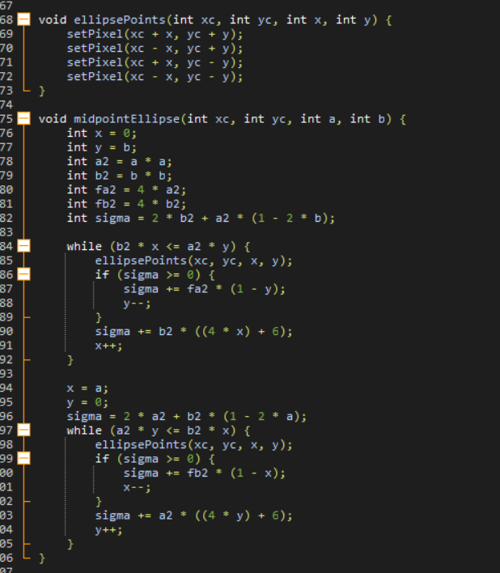

Kết quả:

